Deeper Intimacy With God in Prayer, 1 of 2
April 5, 1017
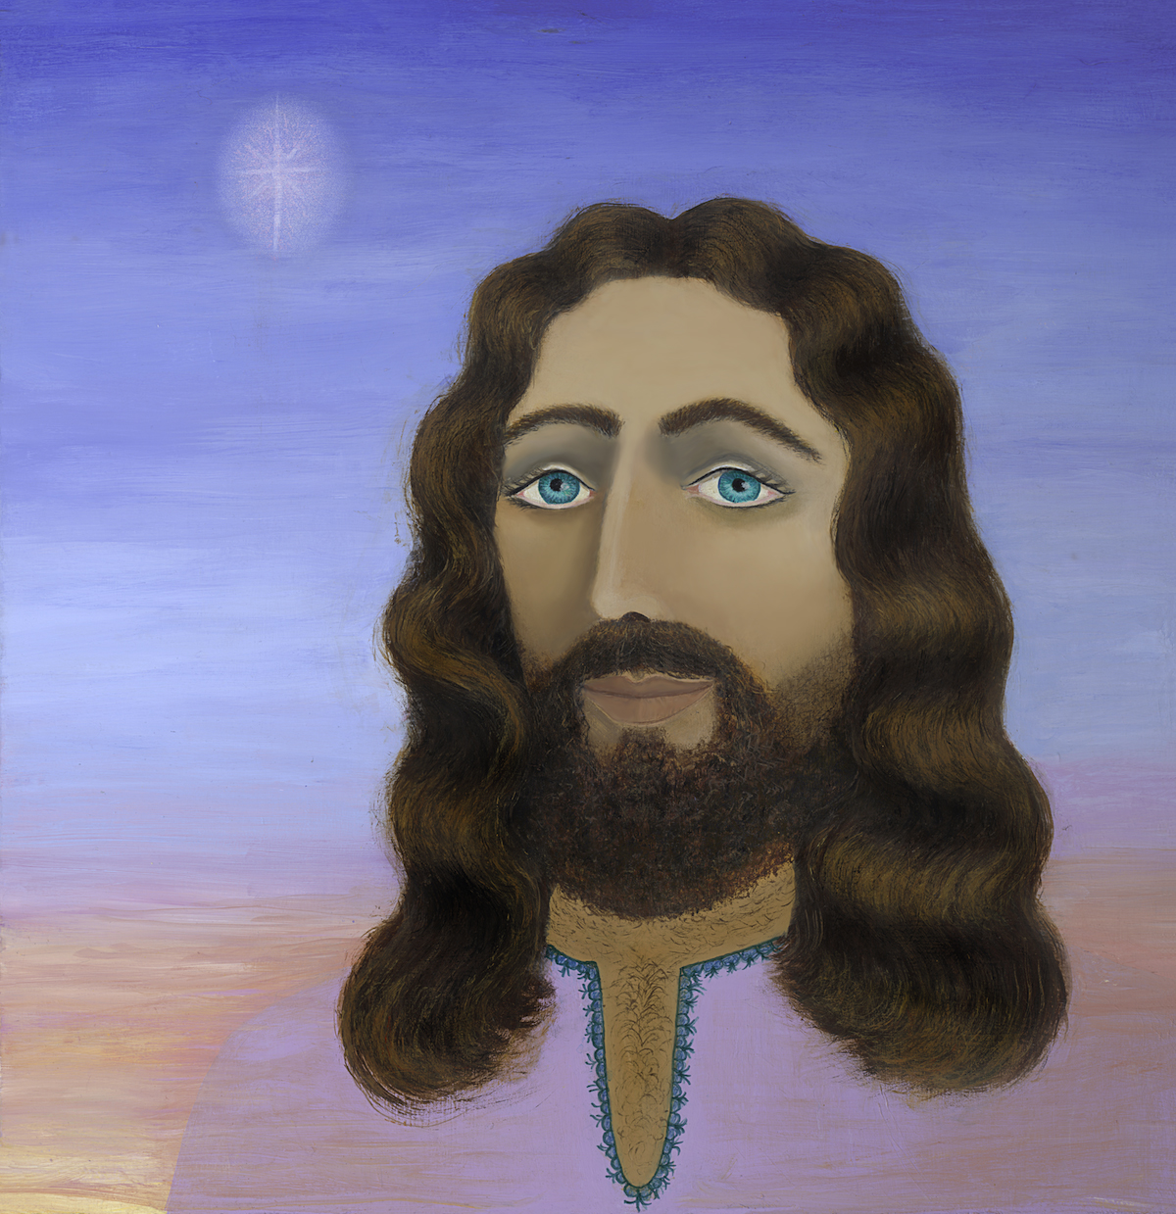
Lord, I pray that your words would resound in our hearts and continue to echo there until we yield ourselves to you every day.

Beloved friends, I have noticed a tendency with me, sometimes - not always. I begin to get very deep in sensing my spiritual union with Jesus, and for some reason I jump up and leave that very sweet place for something totally useless, or get up to use the rest room and allow myself to be distracted when I am only 10 feet away from my prayer room, where we were communing. It happened again today and He addressed it. I hope all of you will benefit from this.

Jesus began, "I want you to draw closer, My dearest. You keep yourself too occupied when I want to feed you My extraordinary love for you from My heart. Here you are talking about distractions and look at how easily you are drawn away from My bosom, when I wish for you to rest there. There is so much more I want to give you, My Love. So much more. But you tend to vault out of My arms just when we are reaching a point of the communion of Our Hearts, for I love to dwell in you and you love to dwell in Me and we belong together.

"But you are easily taken off from this place. Is it your reticence to allow yourself to be vulnerable to Me? Is that why you pull away? Or is it just a simple distraction like getting something to drink?"

Lord, You know the answer to that better than I.

"How about a little of both. The enemy can observe that heart glowing from within you and receiving much needed graces. He knows well how dangerous you will be to his agendas if you receive the fullness of My anointing for you. So, he shoots a thought dart into your head, 'I’m thirsty.' Then when you get up, 'Oh look at this fridge, how did it get so bad? Well, I'll just fix the first shelf real quick.' Then when you’ve finished that, 'Well, I did that. I might as well fix the other shelves, too. After all, I don’t even know what's in there to eat and what needs to be thrown out.' And then he has effectively drawn you away from Me, Clare."

Yep. That's what happened.

"In the meantime, I am watching your reactions to his tactics and wishing you would open your ears and hear Me calling you back. But you have a way of becoming deaf when you spring up into action. By the way, Distraction tells his helper, Deafness, to take care of you, so you won’t hear. Then your angel nudges your husband, 'Tell her not to get distracted.' So he says something, 'Honey, don’t get distracted from the Lord.' And you give him a quickie answer, 'I won’t.' But you know full well you have and you will.

"So I wait.

"How is it that the King must wait for His Queen?"

Oh, that’s not good, Lord. That's not good at all.

"Yes, I know. You lose graces. You hurt Me. I have given Myself to you and you have treated Me of lesser importance than your refrigerator. Do you see this?"

Regrettably, Lord, I do. I was wrong to do that. Lord, please forgive me.

"Will you try harder next time? Actually what I want to say is, will you say 'NO' next time? 'Cause I guarantee you, there will be a next time. As long as the devils are able to do this, they will continue. They stop when you deny them so many times they know their efforts will be wasted because you will turn them down."

Lord, what can I do to repair this damage?

"Come back to Me and linger in prayer for longer. I long for you, as you long for Me. I miss you, Clare. I miss our deep times together. Don’t do to Me what many other ministers do. They cut their time short, because the put tending the flock or personal needs above My need to be with them. Please don’t do that to Me. Do not give that example to your flock. The flock follows the shepherdess, so by your example, My Love, you are bound to live for Me every moment of your life.

"You see, My People, your creative endeavors are only as good and deep as your relationship with Me. If you want to communicate Me to others, you must absorb more and more of Me so you can become like Me. When we are together, I move Heaven and Earth to provide you with fresh manna, fresh anointing, fresh hope and inspiration. When you shortcut that, you shortcut your effectiveness in communicating the Gospel.

"But more importantly, I ask you, what is more important to you: feeding your flock or feeding Me the sweet nectar of your love? So many think I am remote and have no needs whatsoever. I am complete in and of Myself. How wrong they are!!

"Your cats look at you and perhaps think that way because you look so able to feed and groom yourself without their help. But they have come to recognize that you gain emotional strength by snuggling with them and petting them and they bond to you as if you were their birth mother, because you are caring for them as she did.

"The truth is, yes, you can function quite well indeed without your kitties. But you choose not to. You choose to make yourself vulnerable to them, you choose to 'need' them.

"Don’t suppose that I am like a plastic Buddha that has no feelings. I am your Creator, Who created you for the express purpose of having a relationship with Me. I long to be recognized for Who I Am and what I AM to all My creatures.

"The birds, the crickets and even the whales are all aware of this and what scientists do not hear is their worship. Men understand needs being met like mating calls, distress calls, but worship? Oh, men are so far from understanding the sheer delight and pleasure creatures experience when they worship Me."

I'm going to end this message here at this point, and carry on the next message for tomorrow, because He began to cite Scriptures and get into the whole purpose of Creation worshipping Him. It's almost a completely different topic, really, even though the two complement each other.

So, tomorrow will be the next teaching on this.

So, the Lord bless you, dear ones. And don't be foolish like I was. Stay close to Him. When that time is really sweet, don't let anything pull you out of it. If you have to use the restroom or something, do it quickly and come right back. And be aware that the minute you get up, Satan is going to try and sidetrack you and prevent you from coming back and staying in that sweet place.

So, let us be wise as servants and gentle as doves. God bless you.

